**Linux Command and Shell scripting**

1. To check the user logged into the Linux machine.

$ W

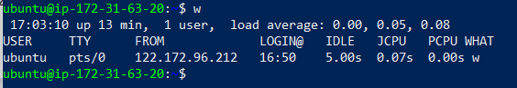

$ who

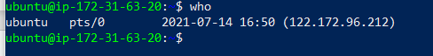

$ whoami



$ id



$ id -g

$ id -gn

$ id -un

$ id -u

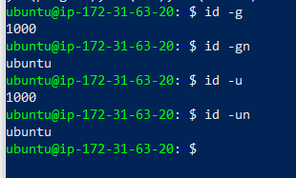

1. To check which shell you have logged into the Linux machine.

Unix provides different flavors of shells:

* Bourne shell (sh)
* C shell (csh)
* TC shell (tcsh)
* Korn shell (ksh)
* Bourne Again shell (bash)

$ echo “$$”

$ ps -p <PID>

$ ps -p “$$”

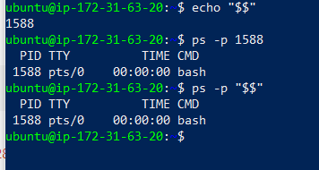

**echo.sh**

#!/bin/bash

echo "Scripting is fun!"

$ chmod 755 script.sh

$ ./script.sh

**Output:**

Scripting is fun!



**Shebang**

#!/bin/csh

echo "This script uses csh as the interpreter."

#!/bin/ksh

echo "This script uses ksh as the interpreter."

#!/bin/zsh

echo "This script uses zsh as the interpreter."

**Sleepy.sh**

#!/bin/bash

sleep 90

$ ./sleepy.sh & [1]

16796

$ ps -fp 16796

UID PID PPID C STIME TTY TIME CMD

jason 16796 16725 0 22:50 pts/0 00:00:00 /bin/bash ./sleepy.sh

**Output:**

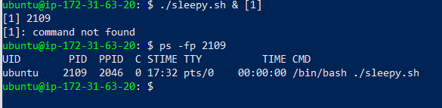

**Variables**

* Storage locations that have a name
* Name-value pairs

**Syntax:**

**VARIABLE_NAME="Value"**

* Variables are case sensitive
* By convention variables are uppercase

**Variable Names**

Valid:

* FIRST3LETTERS="ABC"
* FIRST_THREE_LETTERS="ABC"
* firstThreeLetters="ABC"

Invalid:

* 3LETTERS="ABC"
* first-three-letters="ABC"
* first@Three@Letters="ABC"

**variable.sh**

#!/bin/bash

MY_SHELL="bash"

echo "I am ${MY_SHELL}ing on my keyboard."

**Output:**

I am bashing on my keyboard.

**hostname.sh**

#!/bin/bash

SERVER_NAME=$(hostname)

echo "You are running this script

on ${SERVER_NAME}."

**Output:**



**Making Decisions - The if statement**

if [ condition-is-true ]

then

command 1

command 2

command N

fi

Example: **if.sh**

#!/bin/bash

MY_SHELL="bash"

if [ "$MY_SHELL" = "bash" ]

then

echo "You seem to like the bash shell."

fi

**Output:**



**If/else**

if [ condition-is-true ]

then

command N

else

command N

fi

Example: **ifelse.sh**

#!/bin/bash

MY_SHELL="csh"

if [ "$MY_SHELL" = "bash" ]

then

echo "You seem to like the bash shell."

else

echo "You don't seem to like the bash

shell."

fi

**if/elif/else**

if [ condition-is-true ]

then

command N

elif [ condition-is-true ]

then

command N

else

command N

fi

Example: **ifelifelse.sh**

#!/bin/bash

MY_SHELL="csh"

if [ "$MY_SHELL" = "bash" ]

then

echo "You seem to like the bash shell."

elif [ "$MY_SHELL" = "csh" ]

then

echo "You seem to like the csh shell."

else

echo "You don't seem to like the bash or csh shells."

fi

**FOR LOOP**

for VARIABLE_NAME in ITEM_1 ITEM_N

do

command 1

command 2

command N

done